FLORIDA SPEAKERS ASSOCIATION

“E”VERSITY 2008

THE ART AND CRAFT OF STORYTELLING

Presented by

Mary Lou Williams June 14, 2008

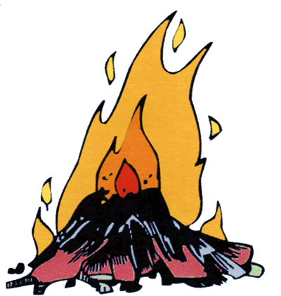

The World of Storytelling

A brief history of storytelling
- Its origin in prehistory
- Its existence in illiterate societies
- How and why it became a lost art
- Places where storytelling stayed alive

The revival of the art of storytelling
- Jimmy Neil Smith, the mayor of Jonesborough, Tennessee, and his inspired idea
- The first annual National Storytelling Festival in Jonesborough

Famous stars of the storytelling world
  - Carmen Agra Deedy
  - Donald Davis
  - Bil Lepp
  - Kathryn Tucker Windham
  - Kevin Kling
  - Willy Claflin

Storytelling as a performing art

A storyteller is just as much a performing artist as an actor, a singer, a dancer, a musician, or a humorist. In fact, many storytellers are also all of the above.

The many hats a storyteller wears
- ______________________________________
- ______________________________________
- ______________________________________

Two famous storytellers in the American mainstream
- ______________________________________
- ______________________________________

Why become a storyteller?

Gain audience attention. Everyone loves a good story
- Convey your message in a story, the best messenger there is
- Be memorable

The story of how I became a storyteller

Introduction to the world of storytelling for adults
- The elderhostel at Appalachia University in Boone, North Carolina
- Charlotte T. Ross, Ph.D., Storyteller
- The first story she told, “An Appalachian Romeo & Juliet”

Membership in Toastmasters

The storytelling manual:
  - Initial motivation - to apply storytelling skills to nutrition Lectures
  - Second motivation - to have fun
  - Reaction to stories I told
- Mystery theatre party game
  - Friend from Kentucky, storytelling country
  - Her suggestion
  - My decision to become a storyteller

A folk tale

“An Appalachian Romeo and Juliet”

The two aspects of the art of storytelling
- the story and the telling

The Story

The three elements of a good story
- Reversal of fortune - the state of affairs at the end must be the exact opposite of the state of affairs at the beginning.

Examples
- ______________________________________
- ______________________________________
- ______________________________________

- Unity of Effect

Examples
  - ______________________________________
  - ______________________________________

- The unexpected ending that is inevitable

Examples
  - ______________________________________
  - ______________________________________
  - ______________________________________

Sources of stories

- The literary story - stories written in books and meant to be read

- The traditional story - stories transmitted orally for hundreds of years

- Folk tales
- Fairy tales
- Tall tales
- Fables
- Myths
- Legends

- The historical story

- The personal story

- Donald Davis - pioneer of the personal story

- The personal story - ideal for incorporation into informational And motivational speeches

- Doug Stevenson, master of incorporating personal stories into Business presentations

- Fractured fairy tales - a reworking of a traditional fairy tale that retains familiar elements such as characters and plot, but alters the story in unexpected ways, often with a contemporary “spin” or ironic twist. From The Oxford Companion To Fairy Tales

Examples of fractured fairy or traditional tales

- Joseph and the Amazing Technicolor Dream Coat
- Into the Woods
- Once Upon a Mattress
- My Fair Lady
- West Side Story
- Shrek
- Wicked

The Telling

Using the tools of the actor's trade

- Vocal variety

  - Volume

  - Pitch

  - Rate

  - Quality

- Body language

- Movement

- Gestures

- Facial expression
- Eye contact
- Props

Learning the story

- Memorizing the words
- Memorizing the structure, improvising the words
- A combination of both

The difference between the actor and the storyteller

- In acting - the fourth wall
- In storytelling - no wall
- The actor performs with the lights down
- The storyteller performs with the lights up

A literary story

“Grand Central Station and Three Red Roses”

QUESTIONS AND ANSWERS

REFERENCES:

Tatar, Maria, The Classic Fairy Tales. New York/London: W. W. Norton & Company, 1999.

Zipes, Jack, Creative Storytelling: Building Community, Changing Lives. NY/London: Routledge, 1995.

STORYTELLING ORGANIZATIONS:

Florida Storytelling Association
P.O. Box 49023
Jacksonville Beach, FL 32240-9023
407-830-6605
www. flstory. org

National Storytelling Network
132 Boone Street, Suite 5
Jonesborough, TN 37659
Toll-Free: 1-800-525-4514
Direct: 423-913-8201
www. storynet. org

International Storytelling Center
116 West Main Street
Jonesborough, TN 37659
Mon.-Fri. 9-5
800-952-8392
423-753-2171
http://www.storytellingcenter.net/

(The National Storytelling Festival is produced by the International Storytelling Center.)

